PAPER SUMMARY REPORT

Efficacy of Using a Digital Health Intervention Model Using Community Health Workers for Primary Health Services in Bangladesh: A Repeated Cross-Sectional Observational Study
Authors | Marzia Zaman, Rubaiyat Alim Hridhee, Refat Ahmed Bhuiyan, Charles Aunkan Gomes, Md. Mashiar Rahman, Sheikh Mohammed Shariful Islam, Farhana Sarker, Khondaker A. Mamun
Venue | BMC Public Health (2025) 25:1833 – Open Access
DOI | 10.1186/s12889-025-22770-9
Affiliations | CMED Health; AIMS Lab/IRIIC & CSE, UIU; PKSF; Deakin University (Australia); Independent University Bangladesh
Research type | Repeated cross-sectional observational study (18 months, three 6-month periods)
Keywords | Digital health, CDSS, AI, NCDs, community health workers, primary healthcare, UHC, SDGs

1. Introduction and Motivation
Primary healthcare in rural Bangladesh lags behind urban areas. The main causes are a shortage of professionals, poor health-seeking behaviour (self-medication, local pharmacists, traditional healers) and low awareness, so chronic diseases are often found late. NCDs cause about 67% of deaths in Bangladesh, and 77% of NCD deaths worldwide occur in LMICs.
Existing digital health services in Bangladesh (telemedicine, online consultation, home sample collection) are mostly urban, and their reach to rural people has not been assessed. CMED Health, working with PKSF, deployed a CHW-led digital model in Somvag Union. An earlier study (Faruque et al., 2019) established its feasibility; this paper evaluates its effectiveness on health outcomes over time.

2. Objective
To evaluate the effectiveness of the digital health intervention model by (i) describing the health status of the served population, (ii) identifying NCD risk factors, and (iii) comparing health vitals across three consecutive six-month periods over 18 months.

3. Methodology
- Intervention model (bottom-up): 14 CHWs (Health Assistants) – one per 500 households, with at least 8 years of schooling and 2 weeks of training – made monthly doorstep visits with a smart health kit (IoT BP monitor, glucometer, SpO₂, temperature, ECG, height/weight). Data went into the “Enriched Sastho” app, and an AI-based CDSS assessed risk and generated digital referrals to Medical Assistants (MATS-certified, could prescribe OTC medicines) or GP doctors (in person or telemedicine), who could refer on to secondary or tertiary care.
- Population and period: all 7,090 households (32,581 people) in Somvag Union, 1 July 2018 – 31 December 2019. Baseline assessment plus KIIs and FGDs, then follow-up every 6 months.
- Measures: BMI, blood pressure, blood glucose (for a small fee), MUAC for children under 7, and self-reported history of hypertension, diabetes, CVD and stroke. Socio-demographic, economic and nutrition variables were also collected.
- Data pipeline: AWS cloud → MySQL dump → Python on Google Colab; data cleaned for invalid values and outliers. Data split into P1 (Jul–Dec 2018), P2 (Jan–Jun 2019) and P3 (Jul–Dec 2019), using each person’s latest measurement per period.
- Statistics: proportions with 95% CIs; multivariate logistic regression (odds ratios) for risk factors (sex, age ≥ 40, obesity, co-morbidities); D’Agostino–Pearson normality test, then t-test/Welch’s t-test or Wilcoxon signed-rank test; two-proportion z-tests across periods; p < 0.05.
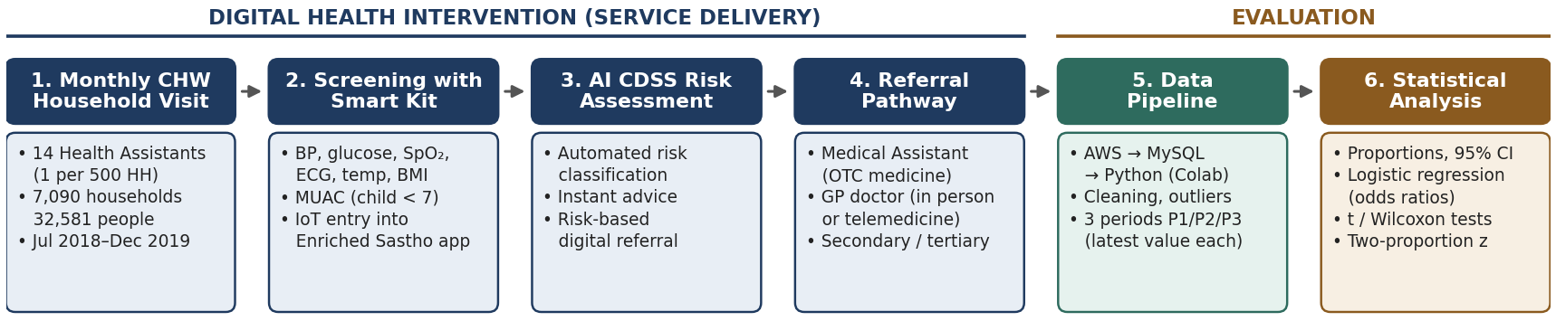
Figure 1. Methodology block diagram – CHW-led digital intervention workflow and evaluation pipeline.

4. Key Results
Population health profile (adults unless noted): 21.76% overweight and 4.06% obese; 78.5% normal BP and 8.18% prehypertension; 16.45% high blood glucose; 11% of children under 7 malnourished and 1.39% severely malnourished. About 64% of people served were under 35.
Risk association (multivariate logistic regression) | Odds ratio (95% CI)
Age ≥ 40 → Hypertension | 13.56 (12.06–15.24)
Age ≥ 40 → Diabetes | 3.96 (3.35–4.69)
Hypertension ↔ Diabetes | 7.16 (6.13–8.36)
Hypertension → CVD | 12.50 (7.54–20.73)
CVD → Stroke | 8.12 (3.76–17.54)

- BMI (P1 → P3): normal BMI rose and underweight fell significantly.
- Blood pressure: the share with normal BP increased and prehypertension and mild-high BP decreased significantly; systolic BP fell significantly between P1 and P3.
- MUAC: the share of nourished children increased and malnutrition decreased significantly.
- Blood glucose – no improvement: the high-glucose share rose. This happened because the test was paid, and people without diabetes stopped testing after normal results, so later periods were dominated by people with known, often uncontrolled, diabetes (1,442 → 435 → 220 tested).

5. Discussion
The prevalence findings are consistent with national surveys (national overweight prevalence 18.9% and obesity 4.6%). Regular monitoring and consultation appear to have slowed progression from prehypertension to hypertension, and awareness of child nutrition improved family practices. Integrating AI decision support with CHW-led screening also addresses the reluctance of doctors to work in rural areas and improves accountability. The authors estimate the model could be self-sustaining at about US$1 per family per month and recommend scaling it through public–private partnerships, with government subsidies, as a route to Universal Health Coverage.

6. Limitations
- The study covered a single rural union, so results may not generalise to urban areas or other settings, and there was no control group.
- Participation was skewed by gender (daytime visits, mostly women), and disease history was partly self-reported.
- Using only the latest measurement per period may introduce selection bias. Retention and referral follow-up were low, and referral data were lost because of server problems.
- Diabetes outcomes were confounded by the paid glucose test.

7. Conclusion and Future Work
Over 18 months the model served more than 32,000 rural people, identified key NCD risks and produced statistically significant improvements in BMI, blood pressure and child nutrition, though not in blood glucose. The authors conclude that CHWs combined with IoT kits and AI-driven CDSS are a feasible, effective and cost-effective way to strengthen rural primary care. Planned extensions include heart-attack risk prediction, a Bangla medical-GPT and symptom checker, face-recognition-based accountability, and AI-driven personalised health insurance.

